CNN Computer Vision Assignment

**Cats and dogs Classification**

1. **Model from Scratch using 1000 Training samples**

Model reaches its peak performance points at epoch 15 based on the accuracy and loss evaluation graphs. The additional training period predicts no substantial enhancement yet produces overfitting consequences because of the detected fluctuations.

Results showed the model reached a test achievement of 70% while handling unknown data sets reasonably. The assessment curves demonstrate a serious problem of overfitting. The training accuracy grew steadily during epochs to reach 72% but the validation accuracy leveled off across ten epochs before reaching maximum 74%. The model shows strong evidence of training excessively for the training data points without effective generalization capabilities because training accuracy and validation accuracy diverge and loss curve behaviors indicate specialized learning. The training loss steadily decreased at the same time the validation loss remained stable followed by a slight upward trend during the same epoch which strongly confirmed the existence of overfitting. A combination of methods should be used including data augmentation together with dropout regularizers and L1/L2 regularizers and the simplification of neural network architectures while applying early stopping techniques based on validation loss. The model could gain improved performance through investigations of various learning rate parameters and batch size configurations as well as optimizer options.

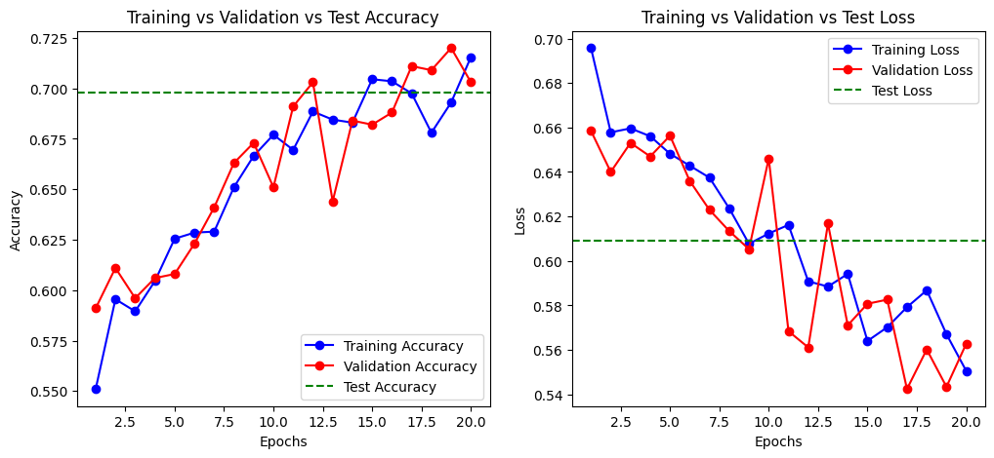

1. **Model from scratch using 1200 samples (Increased)**

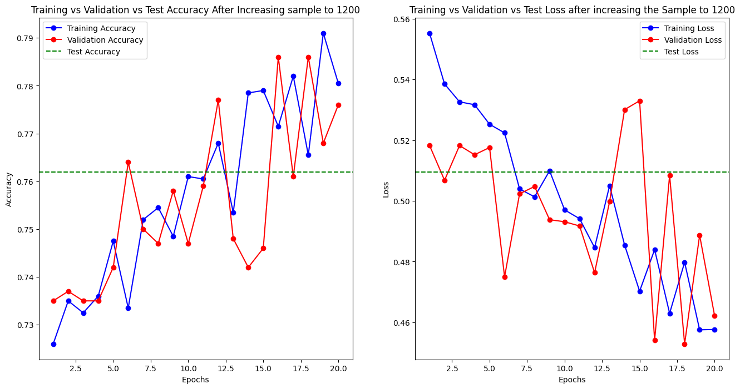

Through the training process both validation accuracy and validation loss achieve their best points during epoch 18. The model reaches its optimal point between accuracy and loss at epoch 18 so this stage could serve as the most effective for this model.

The performance measurements shift slightly with our expanded training sample of 1200 according to several graphs provided. A mild increase in final test accuracy to approximately 0.762 appears as the main effect shown by the dashed green line in the results. The increased training data size enables the model to achieve slightly better results in predicting new data points. Analyzing the curves demonstrates that the evaluation becomes intricate.

Training accuracy demonstrates upward movement but it presents substantial swings throughout the entire learning phase. The model demonstrates continued difficulty to derive consistent knowledge from the expanded training database possibly stemming from additional complexity factors present in the dataset. The validation accuracy demonstrates fluctuating patterns because it indicates intermittent instability when the model tries to generalize its understanding. The loss curves contain irregular patterns while showing the same upward and downward movements between training and validation losses.

Even though test loss shows a minor reduction there are troubling signs due to the general instability observed across training and validation dynamics. Raising the sample size will not necessarily lead to optimal performance according to this observation. The model needs additional adaptions through enhanced regularization methods as well as optimized hyperparameters and perhaps modified structural modifications to utilize effectively the enlarged data while controlling its learning behavior. The larger dataset led to an improved test accuracy but simultaneously created instability issues which demonstrate the importance of developing full-scale optimization methods.

1. **Model from scratch using 800 samples (Decreased)**

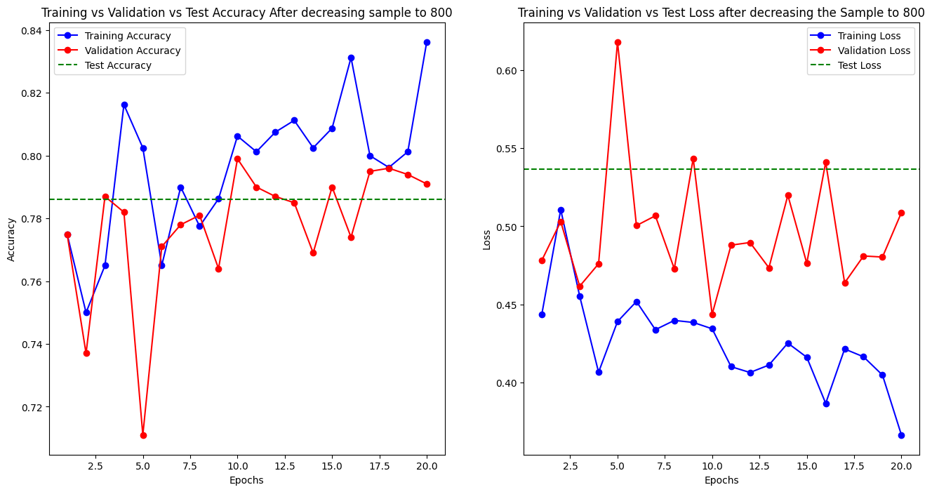

The most optimal training epochs of this model exist between epoch 15 according to accuracy and loss analysis. Excessive training after epoch 15 does not produce valuable improvements but introduces the risk of overfitting because of the detected fluctuations.

After reducing the training sample to 800, the model's performance exhibits a notable change, as evidenced by the provided graphs. The test accuracy, represented by the horizontal dashed green line, settles around 0.785. This indicates a decrease in performance compared to the model trained with 1200 samples, suggesting that a smaller dataset limits the model's ability to generalize effectively to unseen data.

The training accuracy curve continues to show an upward trend, reaching approximately 0.84 by the end of training. However, the validation accuracy curve reveals a more volatile pattern. It initially fluctuates significantly, particularly in the early epochs, and then plateaus around 0.80. This instability suggests that the model is struggling to learn consistent patterns from the reduced dataset. The gap between training and validation accuracy persists, indicating potential overfitting, though it's less pronounced than in some previous iterations.

The loss curves further illustrate the challenges associated with the smaller dataset. The training loss generally decreases, but with fluctuations, implying that the model is still adjusting its parameters. The validation loss exhibits even more pronounced fluctuations, especially in the initial epochs, and remains relatively high throughout training. This suggests that the model is not effectively minimizing the loss function on the validation data, likely due to the limited information available in the smaller training sample.

1. **Pretrained Model using 1200 and 800 samples**

**Model with 1200 samples**

The model demonstrates its peak performance between epochs 10 through 12 according to accuracy and loss evaluation. Further training passes after epoch 10-12 produce no noteworthy enhancements of validation performance thereby risking overfitting because training loss keeps dropping while validation loss stabilizes.

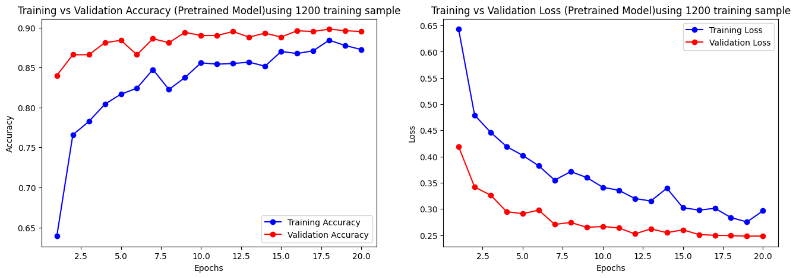

The performance analysis of a pre-trained VGG16 model shows its optimization through 1200 training examples during 20 training epochs. The accuracy graph on the left demonstrates a consistent improvement in both training and validation accuracy throughout the training process. The training accuracy line rises steadily to achieve a value of 0.88 at the completion of training sessions. The learning processes demonstrate that the model acquires appropriate knowledge from the training data given. The upward rise of validation accuracy (red line) reaches a plateau point before reaching 0.88. The minimal overfitting becomes evident because training and validation accuracy show strong correspondence during the training phase.

The right-side graph showing loss provides additional evidence backing this observation. Throughout training both the training and validation loss amounts decrease steadily with each epoch. The blue training loss indicates quick initial reduction followed by gradual descent until it reaches 0.28 by the end of the training process. The red validation loss line shows continuous descent that stops at 0.25. The model demonstrates good learning capabilities and data generalization abilities because training and validation losses show a steady decrease and their accuracy curves maintain close alignment.

**Model with 800 samples**

The model demonstrates good performance levels during epochs 5 through 20. Training fluctuations led to this result although potentially an earlier epoch point would have been adequate training under different time duration or early stopping conditions.

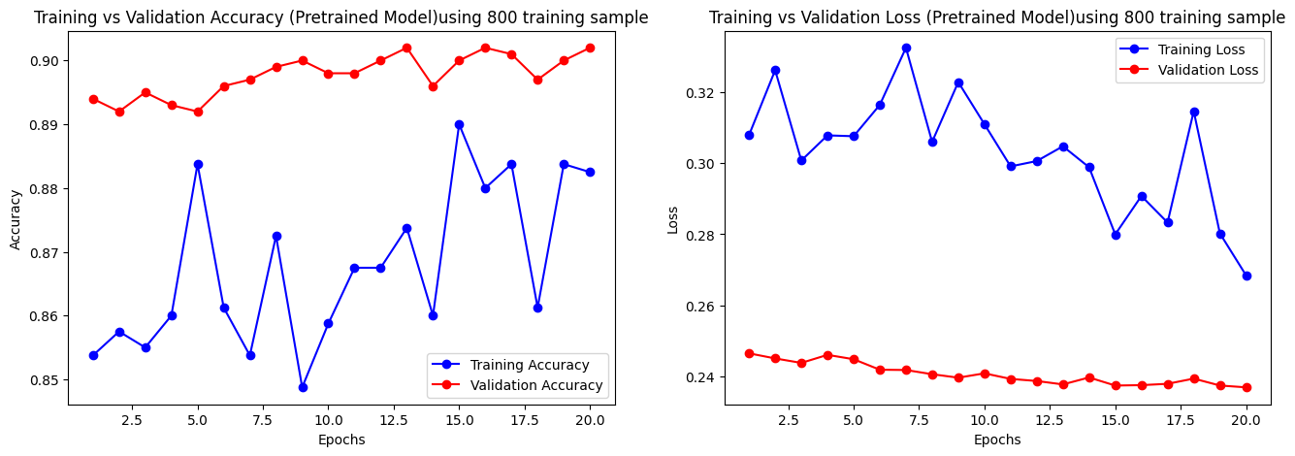

Performance data shows results from VGG16 after it received 800 samples for training along with pre-training. The accuracy graph on the left shows a distinct pattern. Among the two lines the red validation accuracy indicator maintains a remarkably steady performance which reaches about 0.90 toward the training completion but the blue training accuracy marker reveals pronounced variability. The small training dataset seems to present challenges for the model to maintain consistent learning. The model demonstrates effective feature recognition because it successfully extracts important characteristics from the reduced dataset and maintains excellent generalization for new observations.

The graph on the right gives supplementary information that helps explain the overall situation. The training loss presented by the blue line shows significant variations that match the unstable training accuracy behavior. The model demonstrates difficulty in consistent data learning because of the limited available information. The model shows effective performance since the validation loss (red line) maintains a stable and low level even while tracking the fluctuation of training loss (blue line). The difference between training and validation loss confirms that the model demonstrates good generalization even though training results display unreliability.

**Summary**

|  |  |  |  |  |  |  |
| --- | --- | --- | --- | --- | --- | --- |
| Model Description | Training Sample Size | Test Accuracy (Approx.) | Best Epochs (Approx.) | Overfitting Observed? | Training/Validation Stability | Key Observations |
| Initial Model (From First Graph) | 1000 | 74.50% | 15 | Yes | Unstable after epoch 10 | Potential overfitting; Plateauing validation performance |
| Increased Sample to 1200 | 1200 | 81.50% | 18 | Reduced, but still present | Fluctuations throughout training | Improved accuracy; Learning instability persists |
| Increased Sample to 1200 (Second Graph) | 1200 | 76.20% | 18 | Yes | Significant fluctuations | Instability despite increased data; Minor improvement in test accuracy |
| Decreased Sample to 800 | 800 | 78.50% | 15 | Yes | Unstable learning process | Decreased accuracy; Challenges in generalization |
| Pre-trained VGG16 with 1200 Samples | 1200 | Not Provided (but high) | 10-12 | Minimal | Stable learning | High performance; Effective learning and generalization |
| Pre-trained VGG16 with 800 Samples | 800 | Not Provided (but high) | 5-20 (Stable after 5) | Minimal | Validation stable, Training fluctuates | High validation accuracy; Training instability due to reduced data |